MAT-DOC Notes
Mounting Assistive Technology Documentation

INTRODUCTION
The Mounting Assistive Technology (MAT) documentation helps people ensure assistive technology can be used effectively in a range of environments and contexts to enable the use of the technology to be maximised.
It has been developed from the WRAMP documentation that has been in use for some years. A team of professionals involved with providing assistive technology have developed the new documentation and these notes.
Feedback is always welcomed through the website GitHub repository. This is an open source project which means that a collaborative approach to its development is sought to improve the quality of the documentation.
Within these notes we have explained the sections in the documentation itself to ensure the meanings are clear. We have also developed a simple two page, nine-point best practice guidelines. We would urge to read these if nothing else.
Above all, please remember that these guidelines are intended to promote and facilitate independence and participation and not as a mechanism to find barriers to provision of equipment.

Best Practice Guidelines
When mounting assistive technology:
- When selecting mounting solutions, consider all contexts in which the technology will be used.
  - Consider all the locations where the equipment will be required and ensure the mounting solution allows the client to maximise their independence and retain their lifestyle and participation.
  - Some locations may be used infrequently but may still be important. Consider if it is important to facilitate mounting in those locations.
  - Consider all the areas of the home (kitchen, dining room, lounge, bathroom and so on).
- Consider the needs of all those who will interact with the technology.
  - The mounting solution may have an impact on those who do not attend the assessment, or are unable to. Consider their requirements too and contact them for additional information if required.
- Provide equipment that gives flexibility.
  - Two wheelchair mounts may not be as flexible as a wheelchair mount on the most commonly used system and a table mount.
  - Ensure the equipment moves with the user so it remains in the optimum position if they are using a tilting system or wheelchair.
- Position devices and mounts in a protective fashion.
  - If using clamp type mounting systems, consider what will happen if part of the mounting system fails or becomes loose. Try to position it so that if that does occur it will fall away from the user not onto them.
  - If using clamp type systems, try to position the clamp blocks so the ends of the joining tubes are contained in or near the block. This means that there will not be exposed joining tubes that could be a hazard to the user or others.
  - Rigid components of the system can be positioned to protect delicate components such as cables and device socket entries.
- Consider the safety of the user and those around them.
  - Consider the safety of the user and those around them in the environments in which they will use the assistive technology.
  - Let the kit position be determined by the user and the most appropriate position for them to use it.
  - Ensure all safety aspects and risks have been considered. Use risk management to identify uncertainty and investigate any unknown risks or effects.
- Ensure safety testing is relevant and appropriate.
  - Stability testing and driving assessments are two tests that can be used to ensure the user is safe and investigate the impact of the position of the technology before and after.
  - While stability can be considered, positioning assistive technology may have an impact on the performance of a powerchair in other areas such as braking and deceleration. Ensure the user is aware that they should take some time to get used to how the kit may affect the performance of their powerchair.
- Use risk management as a tool to identify uncertainty and opportunities to improve safety not as tool to restrict independence or participation.
  - Use risk management should be used as an enabler to facilitate access not as a barrier.
- Provide user instruction in formats that are relevant and appropriate.
  - Ensure user instructions are concise, useful and relevant. Developing long-winded written instructions for use may be more likely to be ignored. Where verbal instruction is given, make a note that you have given it, and read from a script to ensure instructions given by different team members are consistent.
  - Concise and relevant instructions are more useful to the user than long-winded and protracted information.
- Use commercially available products where possible and bespoke solutions when necessary
  - Try to use off the shelf products where possible but consider bespoke solutions or modifying existing products where they provide a better solution. Commercially available products should have been through some level of testing and may have been on the market for some time. They will have developed a history and may be more reliable than bespoke solutions. They are also typically quicker to get into use. Don’t rule out bespoke solutions if it provides a better result for the client. Keep it simple and remember efficiency. Follow manufacturers guidelines where possible.

USING THE DOCUMENT
The main MAT-DOC is available as a Microsoft Word Document which can be completed on your computer, or printed and filled in manually. Some fields in the document properties have been used so you will only need to enter the information once, and the relevant parts of the document will be completed automatically.
To open document properties, click the ‘File’ tab in Microsoft Word, and click ‘Show All Properties’ towards the bottom right. This will reveal the ‘Subject’ and ‘Company’ properties which we use to store the client name or reference and your service name respectively.
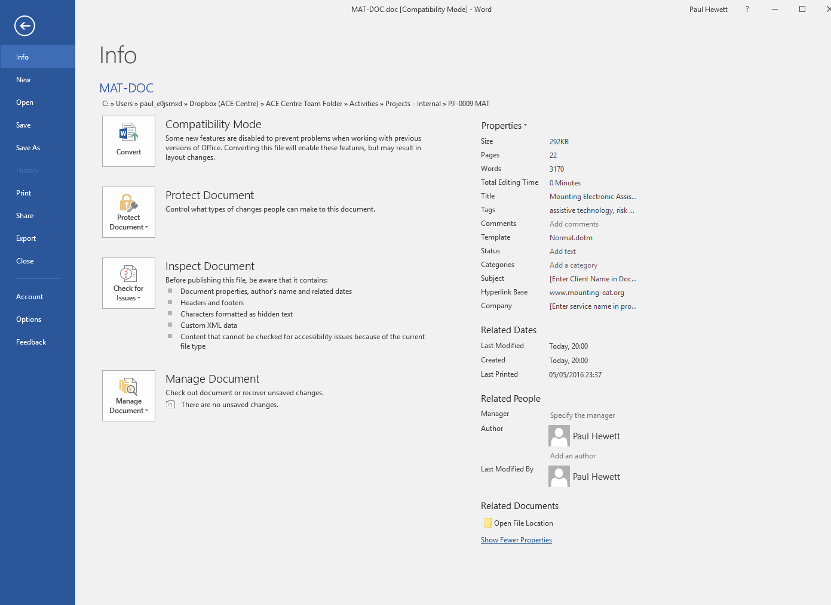
We recommend that you avoid using any client identifiable information in the document, and you use a client reference in the ‘Subject’ field.
The document has been produced with a grey background which will not be shown when you print the document. This enables the areas that need to be completed to be easier to see. The areas that need completing are shown in white.

SUMMARY SHEET
Once you become competent in mounting, you may find it unnecessary to always be referring to the complete documentation. We have produced a summary sheet that enables you to record the important information and that you have considered all relevant factors. You can use the main document as a reference, but complete the summary form once you are comfortable with the full contents of MAT-DOC.
If the mounting is particularly complex, or you need to complete a risk assessment as part of the provision, or carry out a stability test of driving assessment, we would recommend you use the complete form in place of the document summary.

Section 1 – Pre Assessment Information
This section can be used to gather information before considering the type of solutions you might like to provide. It is always worthwhile at this stage to take or obtain some photographs of any wheelbases that are being considered, in particular with the proposed device and any accessories in the approximate position in which it is likely to be used.
Much of this information could be completed by other members of the team, or a teacher or parent for example.
It is useful to ask about the environment so a mounting solution can be provided that best meets the user’s lifestyle needs. There is little point mounting to a wheelchair if it is only used for 30 minutes per day to get to and from school. Other bases may be more appropriate.
You can start to make some initial decisions in this section which will be looked at in more detail later on.

SECTION 2 – WHEELBASE INFORMATION
It is likely that mounting to at least one wheelchair will be required. It is important to ensure that the sum of the weight of the equipment you are planning to mount, the equipment that has already been attached to the wheelchair (such as a special seating unit), and the user’s own weight falls within the weight limit of the chair.
If we are attaching a switch or a light device such as an iPad onto a powerchair, it has little impact on stability. If we are attaching a large eye gaze at nearly 4kg in front of the user it has a bigger impact. Some AAC devices are becoming smaller and may be positioned close to the user, others are getting larger and need positioning further away from the user. They may be higher risk.
Use this section to note all the relevant information on the wheelbases you may wish to mount to. This information should normally be on labels on the chair, one from the manufacturer, and often one from the service or organisation that supplied the base.

Section 3.1 – Feasibility of Wheelchair Mount
You can use the decision tree below to help you establish if you should proceed with your proposed solution, or if additional investigation or risk assessment is required.
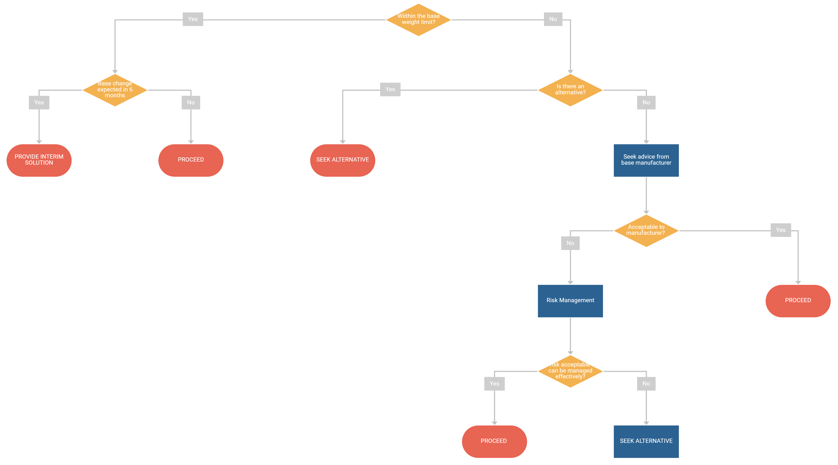
You should be careful to ensure that all relevant factors have been considered when selecting the type of mount to use, and for its location on the wheelbase.

SECTION 3.2 – Feasibility of DESK/TABLE Mount
You can use the decision tree below to help you establish if you should proceed with your proposed solution, or if additional investigation or risk assessment is required.
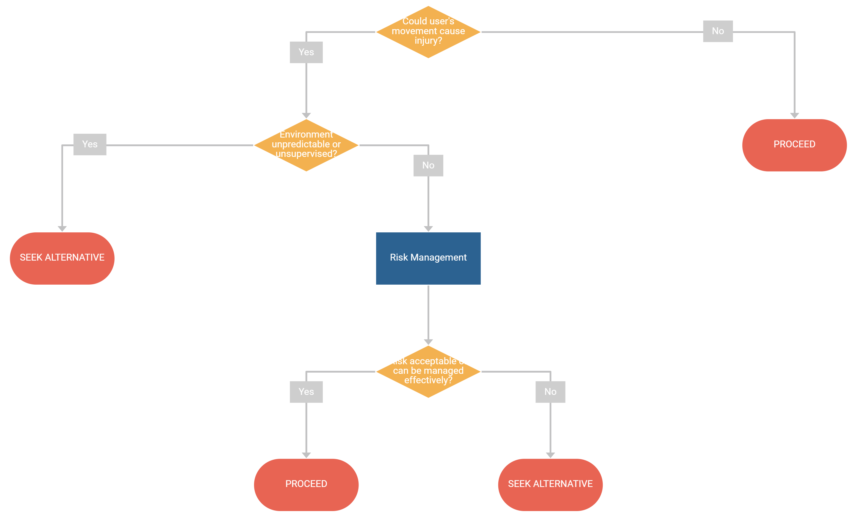
You should be careful to ensure that all relevant factors have been considered when selecting the type of mount to use, and for its location on the wheelbase.

SECTION 3.3 – Feasibility of FLOOR Mount
You can use the decision tree below to help you establish if you should proceed with your proposed solution, or if additional investigation or risk assessment is required.
You should be careful to ensure that all the factors listed have been considered when selecting the type of mount to use, and for its location on the wheelbase.
Floor mounts can be surprisingly challenging to get right. Space can be a real issue in some environments, especially when a large device may require a large floor stand. Moving a floor stand can be difficult, and they can create trip hazards partiularly for the very young or very old if not managed well.

SECTION 3.3 – Feasibility of BESPOKE/HYBRID Mount
You can use the decision tree below to help you establish if you should proceed with your proposed solution, or if additional investigation or risk assessment is required.
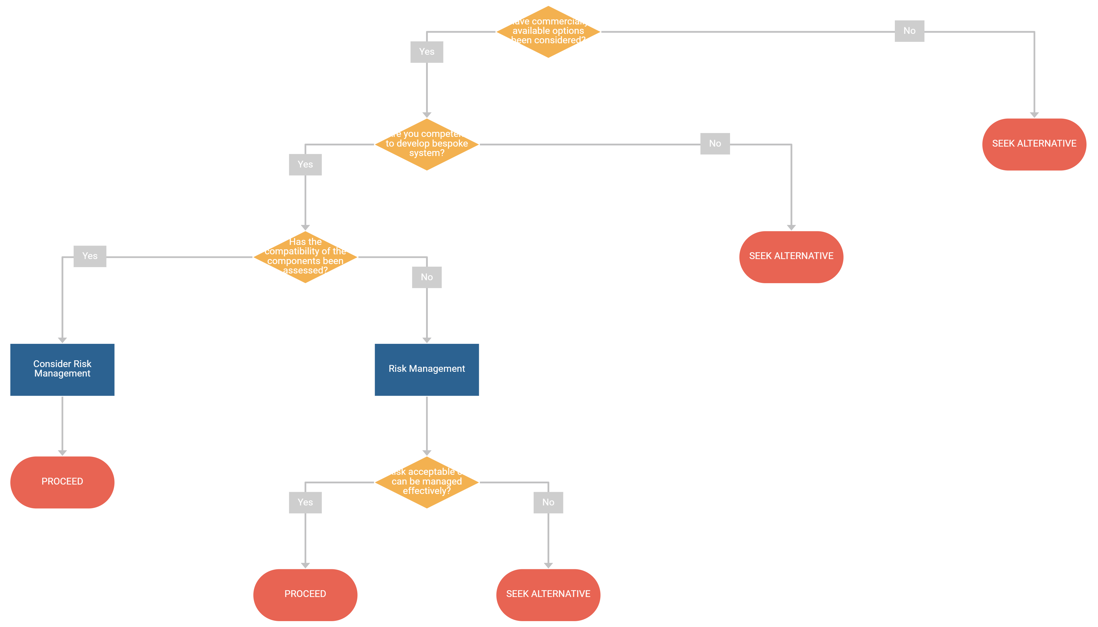
You should be careful to ensure that all the factors listed have been considered when selecting the type of mount to use, and for its location on the wheelbase.

Section 4 – Wheelbase STABILITY ASSESSMENT
We’ve provided this assessment to help guide your decision-making around static stability testing. It should not be considered definitive; you may disagree with some of the assumptions or want to change the scoring. It can be useful though, to help identify situations of risk or areas of uncertainty which you may wish to investigate further.
You should, however, consider these comments on static, as opposed to dynamic stability testing.
Static stability testing is used by some services to determine whether a wheelbase is safe to use once modified to include a seating system or other devices. It is a measure of static stability and uses a pass or fail criteria. In the case of a pass, it gives no indication of how easily the system passed.
Where static stability testing is carried out, services often test to 12 degrees for attendant chairs, and 16 degrees for powered and self-propelled chairs.
MHRA guidance (DB2004) implies that load cell methods for measuring static stability are preferred as they have a lower risk for clients and clinicians carrying out the test.
It is important to consider wheelchair manufacturers’ information on the safe usage of their products.
A powerchair typically used by wheelchair services has a maximum slope of 10 degrees and a maximum kerb height of 6cm specified in the user manual.

To put this into context:
- A typical kerb height is likely to be more in the region of 10cm height. On a typical powerchair this equates to a 12 degree ramp once the castors are at the higher level.
- Wheelchair ramp manufacturers recommend ramp rate of no more than 1 in 12. This equates to 5 degrees.
- 1 in 15 (4 degrees) is the recommended maximum concrete slope, with 1 in 20 (3 degrees) preferred.
We need to consider the risks of doing a static stability test versus the risks of not doing a stability test. It may be that a driving test in the user’s environment is more useful.
While it can be difficult to measure, dynamic stability is also crucially important. Dynamic stability is particularly important for those users who are:
- Moving independently with powered mobility
- Moving independently with self-propulsion
The least stable conditions can occur when:
- stopping when travelling downhill
- accelerating from a standstill uphill
- navigating obstacles such as ramps or kerbs

Section 5 – WHEELCHAIR STATIC STABILITY TEST RESULTS
Should you or the local wheelchair service decide that a static stability test is useful, you can record the results in this section. You may choose to complete several tests to investigate various circumstances, or look at how the location of the device is affecting stability with high risk configurations. In that case, use several sheets if you need to in order to record all the results.

SECTION 6 – DRVING ASSESSMENT
A driving assessment may be useful if you have concerns about the user’s ability to navigate their environment. Driving could be more challenging once the assistive technology has been mounted to the wheelchair. Look for signs on the wheelchair for damage, particularly at the extremities (sides of armrests, castor forks or housings, footplates) as well as areas around the home (door frames, skirting board, plaster) – these can be an indicator that navigation is tight or tricky somewhere – find out where the issue is.
If you feel a driving assessment is necessary, this section of the form will help you identify any issues. You could also use it to identify the impact adding the assistive technology has had on driving or driving accuracy. It may lead you to consider a mount with two mounting positions, or a mount that can be folded out of the way.

SECTION 7 – Risk Management
This section can be used to help you quickly identify risks and hazards and to document them, and identify when a more detailed risk management is required.
You may find that your organisation or trust has their own risk management policy which you may need to use. Even so, the Risk Identification Checklist can help you note down and think about any potential problems with the system, or any other uncertainty.
Use the checklist to list the hazard (e.g. device obscures view) and the risk (e.g. drives into obstacle). If you feel it’s unlikely the hazard will occur, you can document a ‘No’. If you think it might, or you don’t know, you can document a ‘Yes/Don’t know’ and investigate the issue further.
The Risk Analysis part of the process allows you to note all the risk identified in the checklist and then to methodically record the Severity (‘S’) if the risk occurred, and the Probability (‘P’) of it happening. These two numbers are then multiplied together to obtain the Total (‘T’).
You can choose to use one of the example Risk Matrices provided. Use this, and the terminology definitions to determine what course of action to take.

SECTION 8 – Safety and Handover Information
It is important to ensure the client is fully aware of how to operate any equipment you provide, and in particular any important safety issues.
Please remember that most people do not read instructions so providing 50 pages of documentation will not help them to be safe. It is important to find a way that communicates important and relevant issues effectively.
One way to do this is to have a small (perhaps no more than ten) number of key bullet points of the most pertinent information. This can be given to the user verbally at the time of handover, as well as in the printed information.
You may also find it useful to provide information that is relevant to the particular configuration you are providing. One format is shown in the section ‘Information Specific to this Configuration’ section. Here the sentence in each paragraph that is most relevant, based on your judgement and any risk management outcomes, can be retained with the sentences that do not apply being deleted. This should leave you with once sentence per paragraph, and a list that will be relevant and pertinent to the user.
The remainder of this section can be changed to suit you and your service needs, based on the policies of your organisation.

ACKNOWLEDGEMENTS

